Task 1: (8 Marks)
- Go to the official AWS website and click on Create an AWS Account.
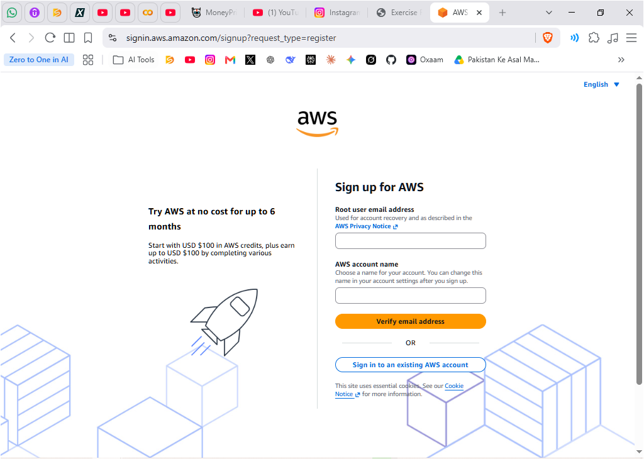
- Enter your email address, choose an AWS account name, and create a strong password.

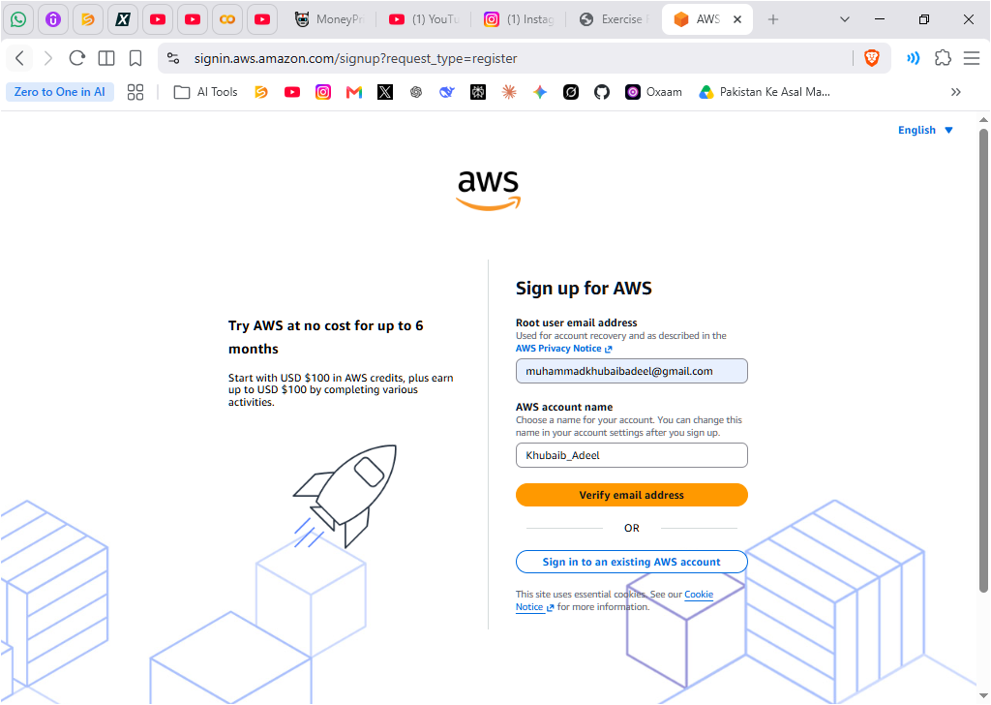
- Complete the email verification process.
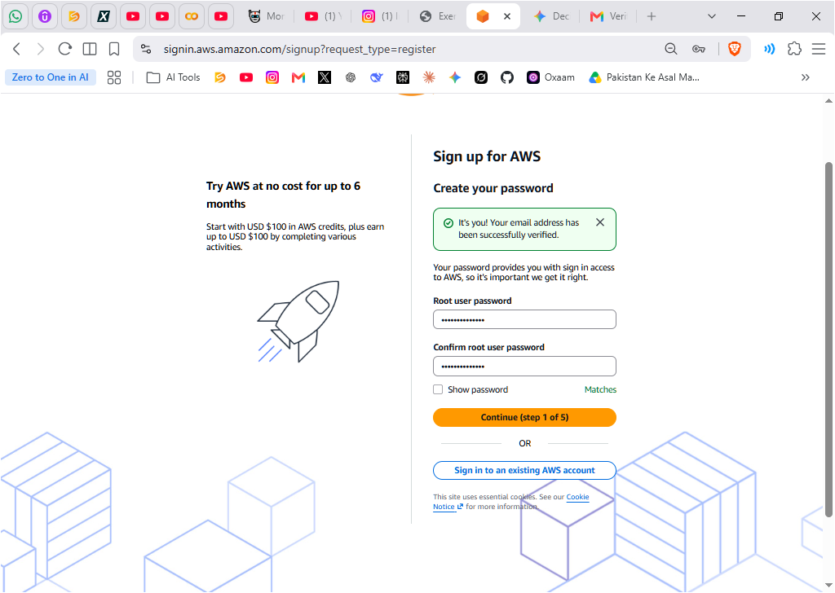

- Fill in your contact information (full name, phone number, and address).
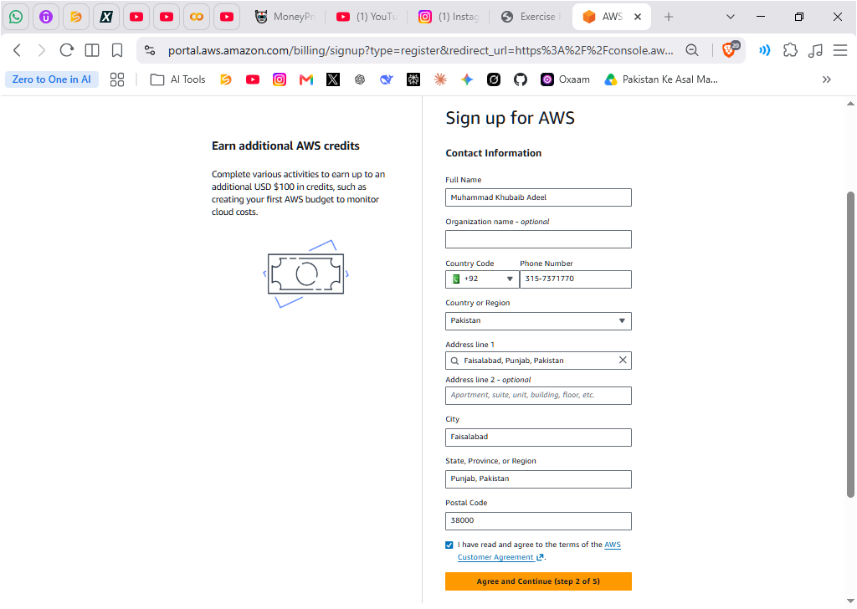
- Add a valid payment method (credit/debit card).
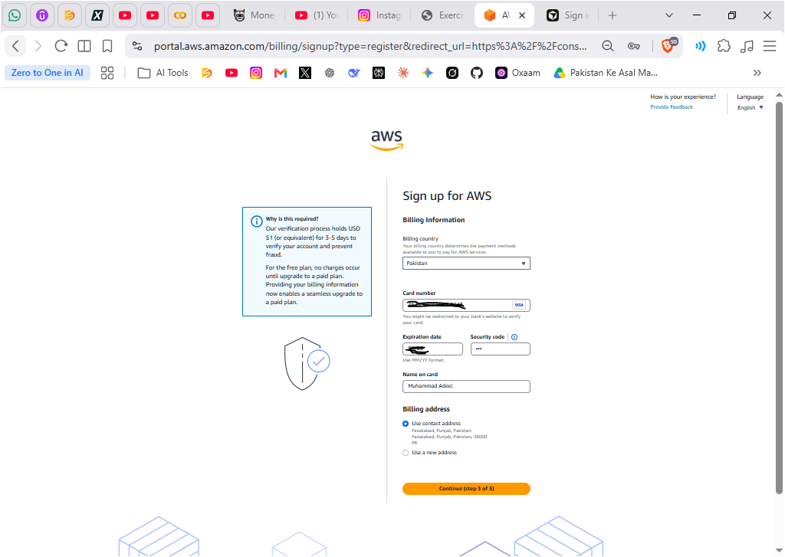
6. Complete the identity verification step (SMS or voice call).
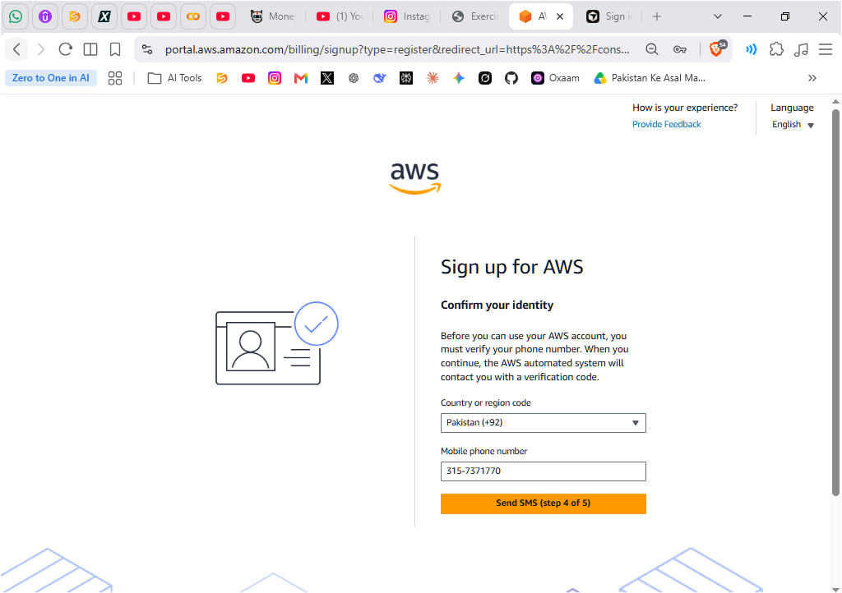
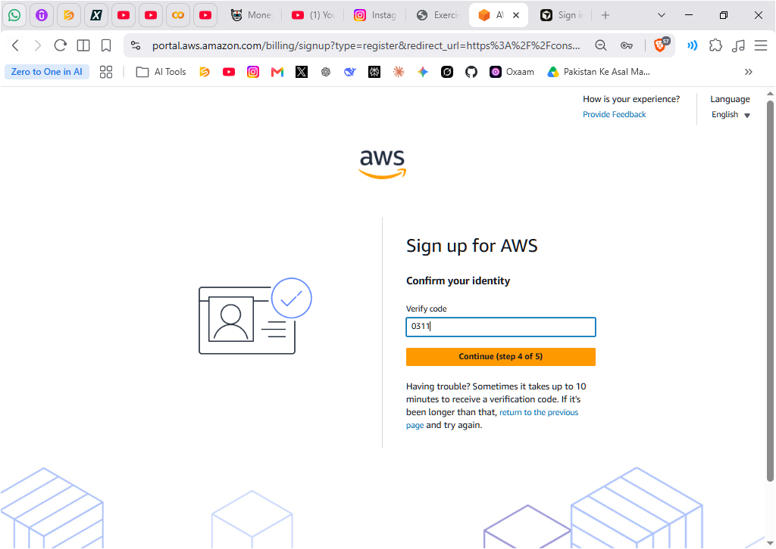
- Select the Basic Support – Free plan and complete the account creation.
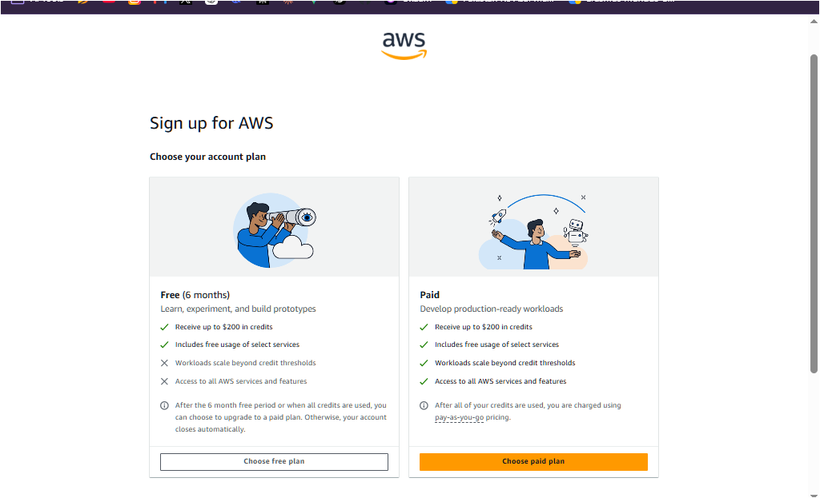
Completed Account Creation:

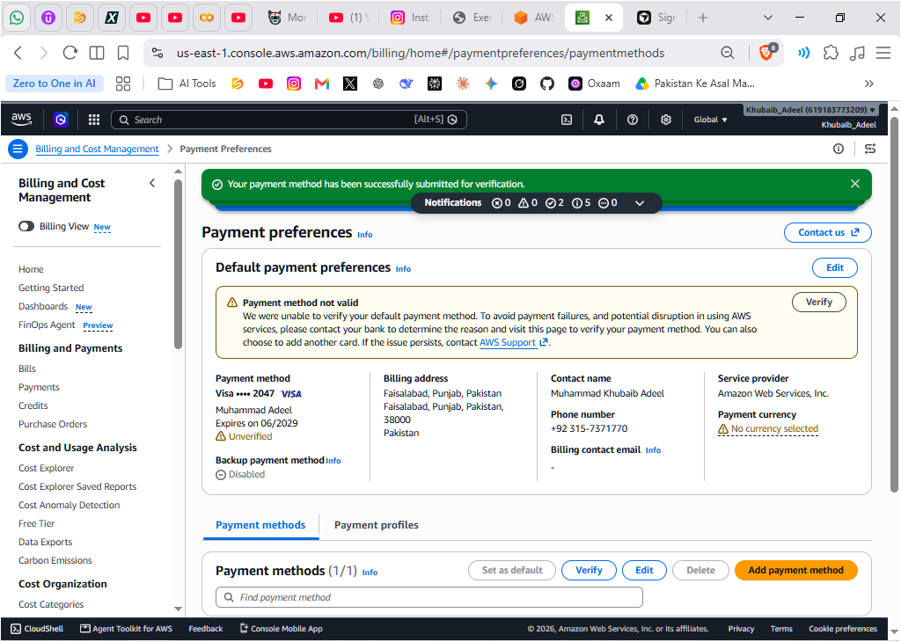
Task 2: (2 Marks)
- Sign in to the AWS Management Console as the Root user.

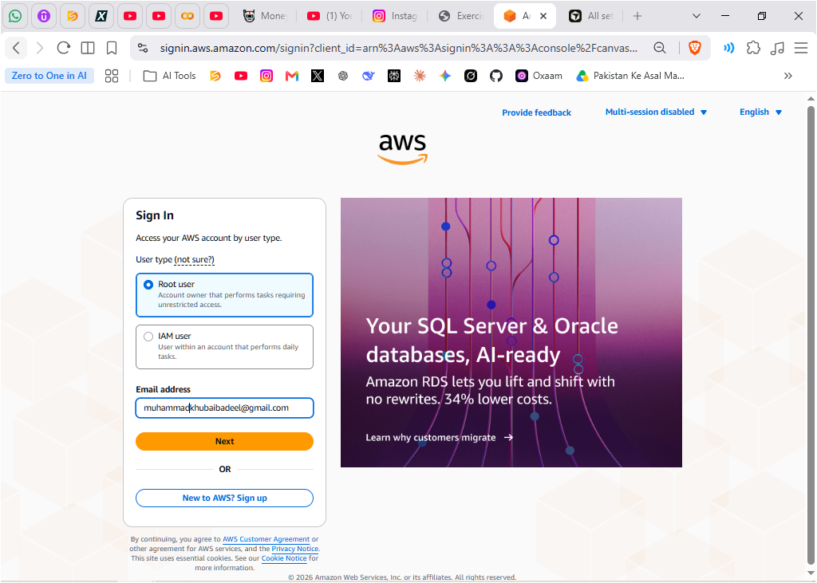
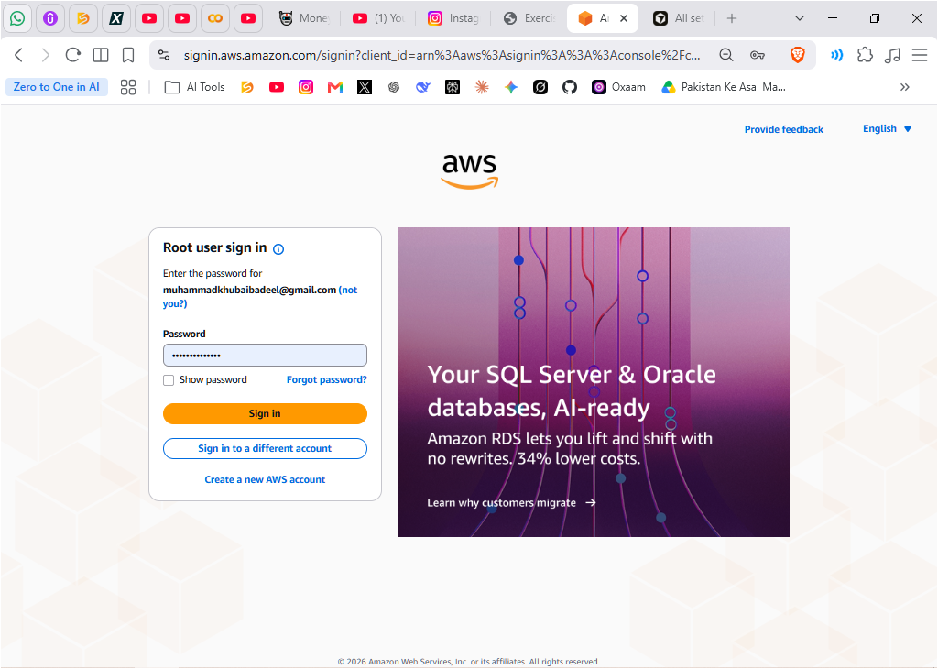
- Enable Multi-Factor Authentication (MFA) on the root user using an authenticator app (Google Authenticator, Microsoft Authenticator, or Authy).

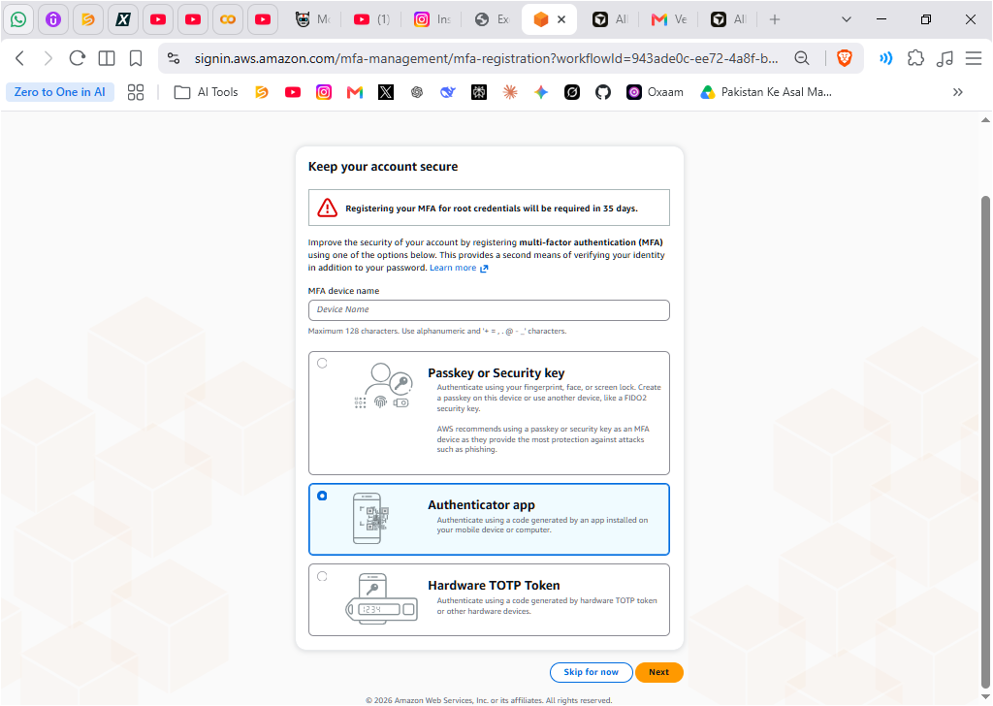
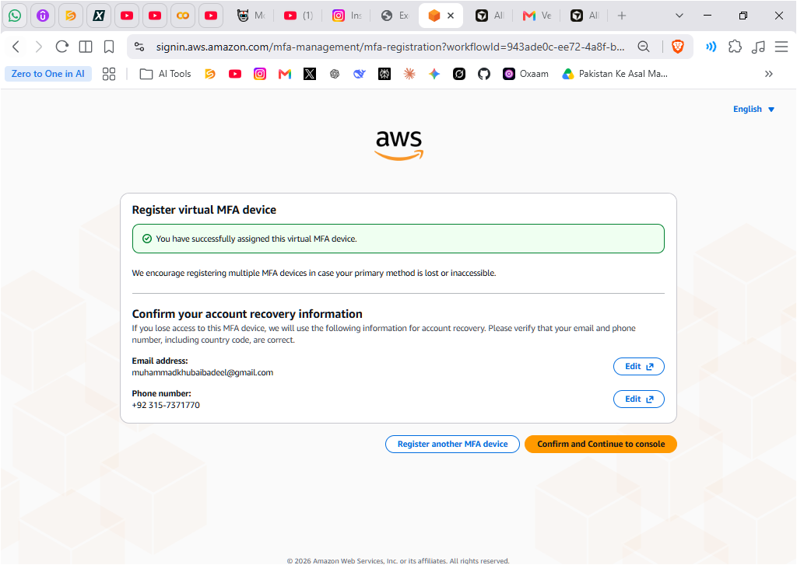
- Sign out of the console and sign in again to verify that MFA is working.
The Multi-Factor Authenticaton is working:
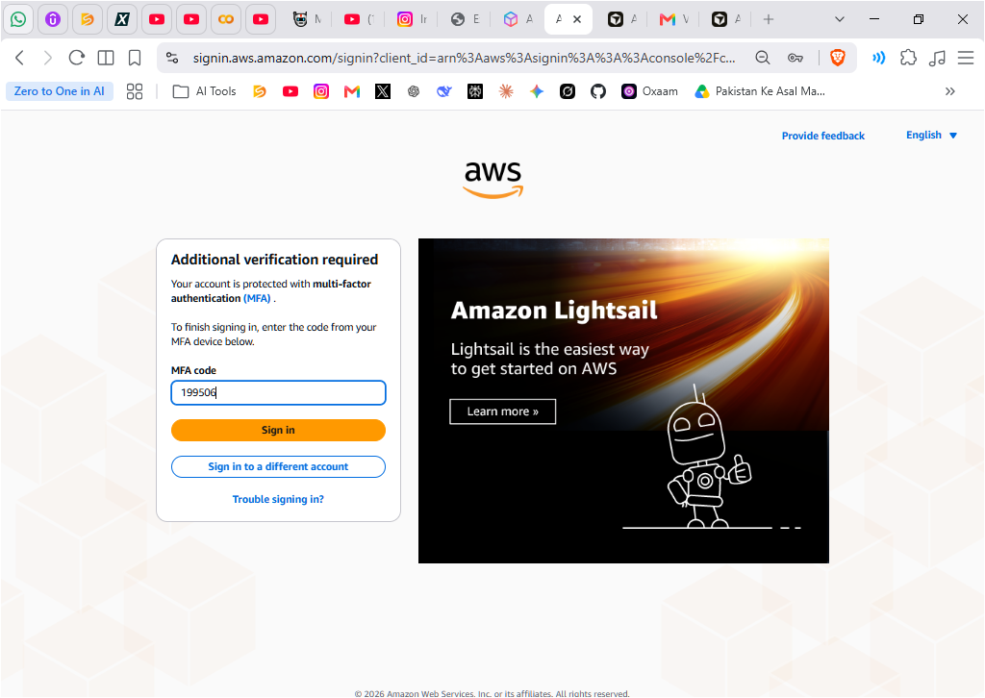

Everything is DONE!
